SALES PERFORMANCE ANALYSIS USING THE SUPERSTORE DATASET
Abstract
Sales performance analysis plays an important role in helping organizations understand revenue generation, profitability, customer behavior, and regional performance. This project analyzes the Superstore dataset using Python, Pandas, Matplotlib, and Seaborn. Various visualizations were created to identify trends in sales, profits, customer segments, regions, and discount strategies. The findings provide insights that can support better business decision-making and improve overall profitability.

1. Introduction
In today's competitive business environment, organizations rely on data analytics to make informed decisions. Sales data contains valuable information regarding customer preferences, product performance, regional demand, and profit generation.
The objective of this project is to perform exploratory data analysis on the Superstore dataset and identify meaningful business insights using visualization techniques. The analysis helps understand sales trends, profitability patterns, and factors affecting business performance.
2. Objectives
The major objectives of this project are:
• Analyze overall sales and profit performance.
• Identify top-performing product categories.
• Examine regional sales and profit distribution.
• Analyze monthly sales trends.
• Study the relationship between discounts and profitability.
• Identify top customers contributing to revenue.
• Generate actionable business insights from the data.
3. Dataset Description
The dataset used for this project is the Sample Superstore Dataset.
Dataset Characteristics:
- Total Records: 9,994
- Total Columns: 21
- Dataset Type: Retail Sales Data
Important Features:
- Order ID
- Order Date
- Customer Name
- Segment
- Category
- Sub-Category
- Region
- Sales
- Quantity
- Discount
- Profit
The dataset contains information related to customer orders, products, sales amounts, discounts offered, and profits earned.

4. Tools and Technologies Used
Software:
- Visual Studio Code
- Jupyter Notebook
Programming Language:
- Python
Libraries:
- Pandas
- NumPy
- Matplotlib
- Seaborn
Version Control:
- GitHub

5. Data Preprocessing
Before analysis, the dataset was examined for quality issues.
Data Cleaning Activities:
- Loaded the CSV dataset using Pandas.
- Checked dataset dimensions and column names.
- Examined data types.
- Checked for missing values.
- Checked for duplicate records.
- Verified numerical attributes.
Results:
- Missing Values Found: 0
- Duplicate Records Found: 0
- Dataset Status: Clean and ready for analysis

6. Exploratory Data Analysis
6.1 Sales by Category
sales_category = df.groupby("Category")["Sales"].sum()
plt.figure(figsize=(8,5))
sales_category.plot(kind="bar")
plt.title("Sales by Category")
plt.xlabel("Category")
plt.ylabel("Sales")
plt.show()
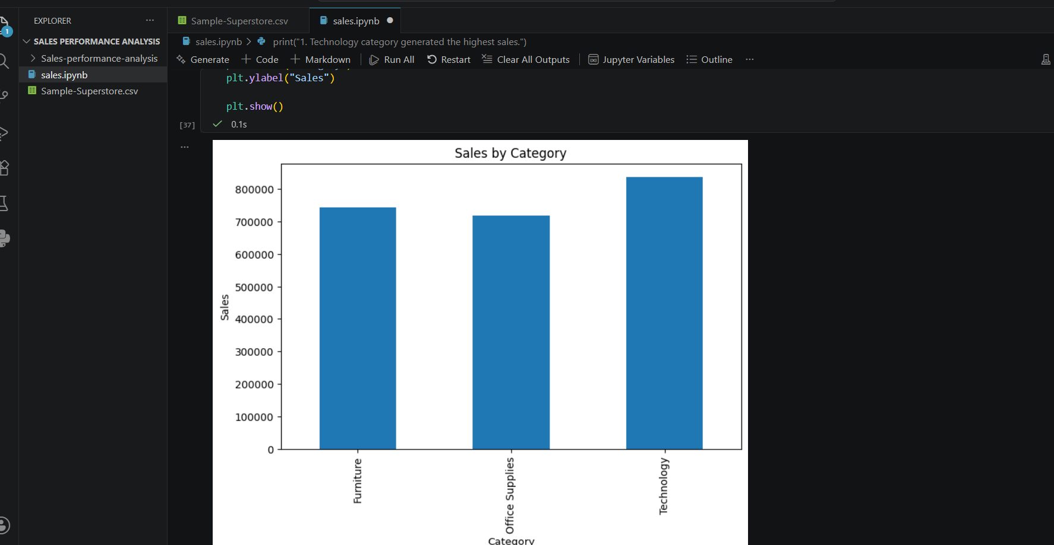
This chart compares total sales generated by each product category.
Observation:
Technology generated the highest sales among all categories, indicating strong customer demand for technology products. Furniture and Office Supplies also contributed significantly to overall revenue.

6.2 Profit by Category
profit_category = df.groupby("Category")["Profit"].sum()
plt.figure(figsize=(8,5))
profit_category.plot(kind="bar")
plt.title("Profit by Category")
plt.xlabel("Category")
plt.ylabel("Profit")
plt.show()
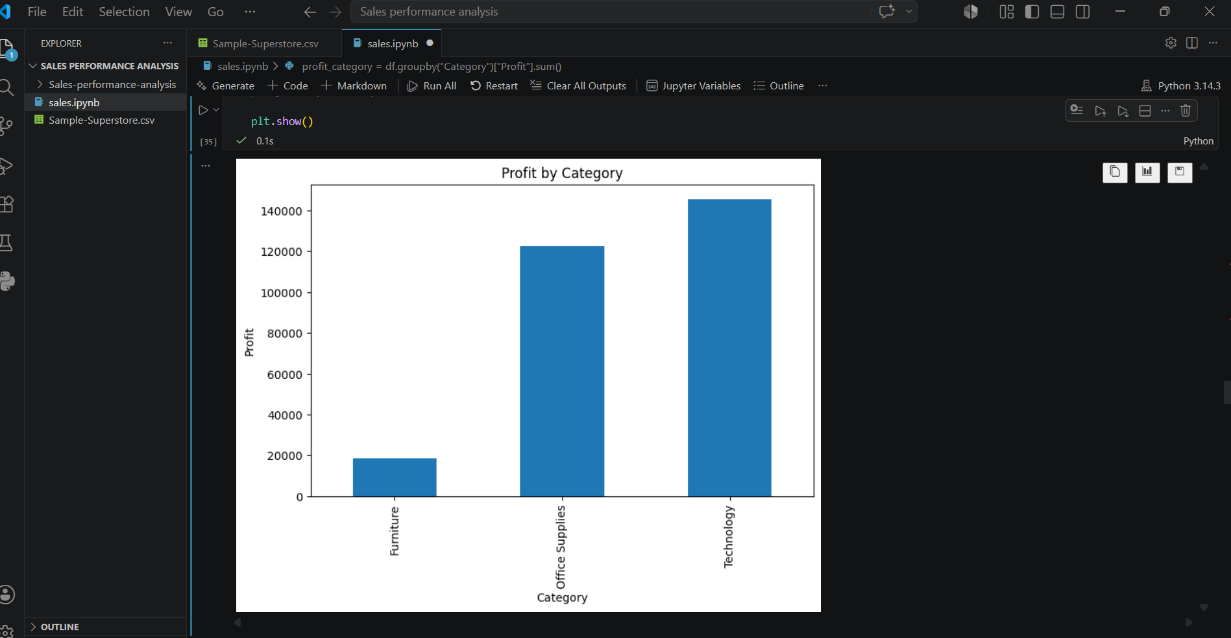
This visualization shows category-wise profit distribution.
Observation:
Technology products generated the highest profit, demonstrating both strong sales volume and favorable profit margins.

6.3 Sales by Region
sales_region = df.groupby("Region")["Sales"].sum()
plt.figure(figsize=(8,5))
sales_region.plot(kind="bar")
plt.title("Sales by Region")
plt.xlabel("Region")
plt.ylabel("Sales")

plt.show()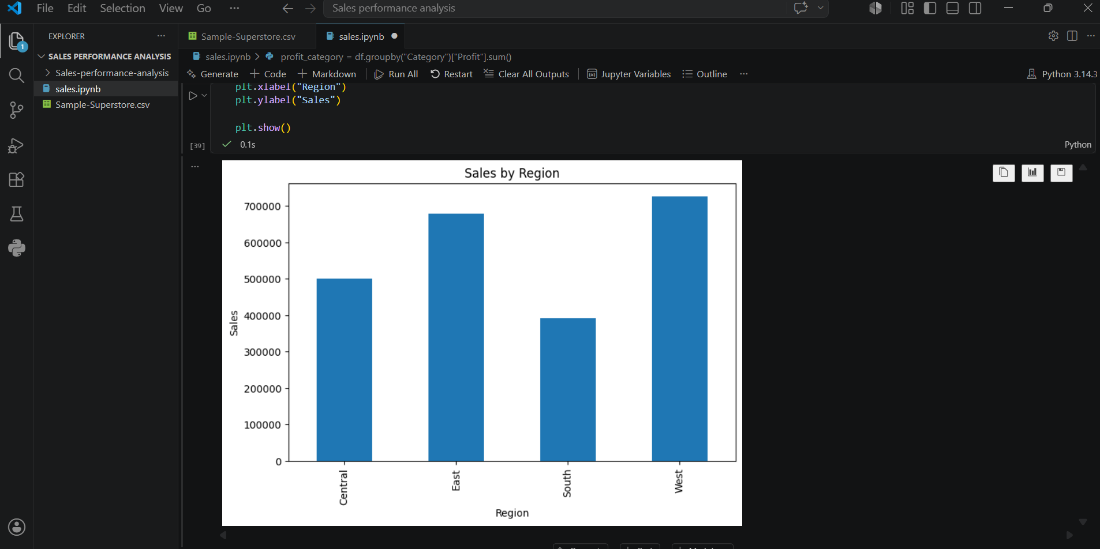
Regional sales analysis helps identify the strongest markets.
Observation:
The West region contributed the highest sales volume, followed by other regions. Regional differences suggest varying customer demand and market opportunities.

6.4 Profit by Region
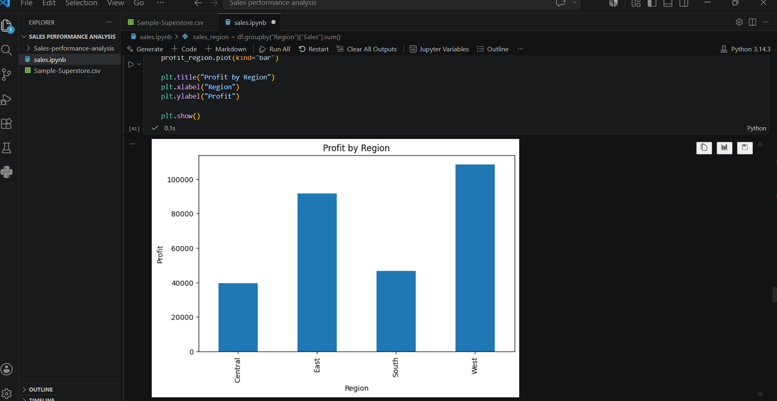
This chart illustrates profit earned across different regions.
Observation:
Certain regions generated significantly higher profits, indicating better business performance and operational efficiency.

6.5 Top 10 States by Sales
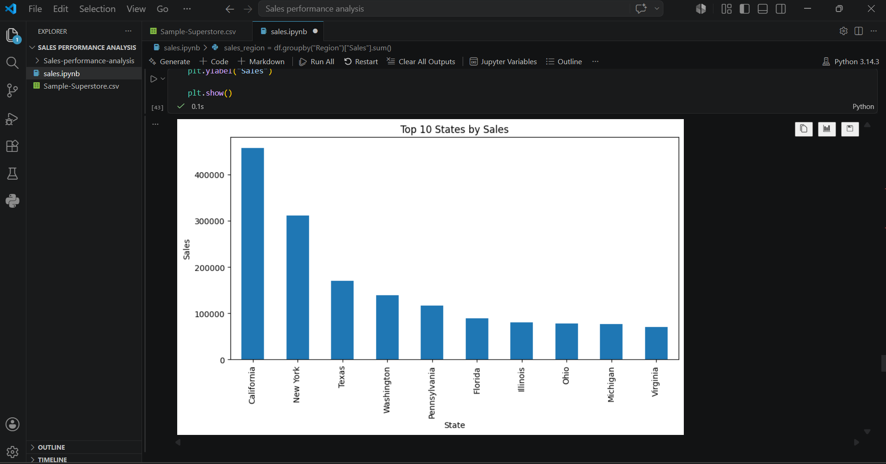
The chart displays the states generating the highest sales.
Observation:
A small number of states contribute a large proportion of total revenue. These locations represent important target markets for future business expansion.

6.6 Monthly Sales Trend
df["Month"] = df["Order Date"].dt.month
monthly_sales = df.groupby("Month")["Sales"].sum()
plt.figure(figsize=(10,5))
monthly_sales.plot(kind="line", marker="o")
plt.title("Monthly Sales Trend")
plt.xlabel("Month")
plt.ylabel("Sales") plt.show()
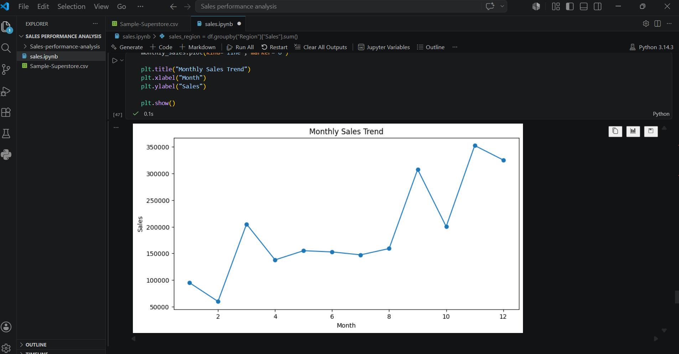
Monthly sales trends help identify seasonal demand patterns.
Observation:
Sales fluctuate throughout the year, with some months showing significantly higher sales than others. Seasonal patterns can be used for inventory planning and marketing strategies.

6.7 Discount vs Profit Analysis
import seaborn as sns
plt.figure(figsize=(8,5))
sns.scatterplot(
x="Discount",
y="Profit",
data=df
)plt.title("Discount vs Profit")
plt.show()
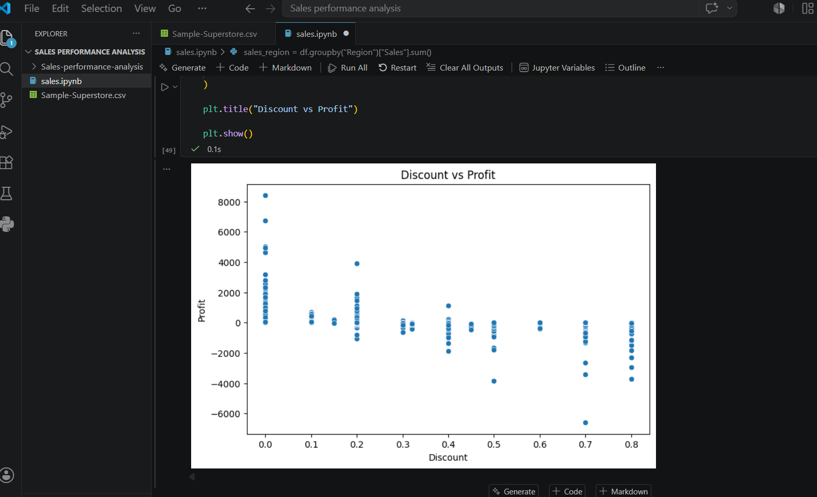
This scatter plot shows the relationship between discounts and profitability.
Observation:
Higher discounts often lead to lower profits. Excessive discounting may negatively impact overall business profitability.

6.8 Sales Distribution by Segment
top_customers = (
df.groupby("Customer Name")["Sales"]
.sum()
.sort_values(ascending=False)
.head(10)
) plt.figure(figsize=(10,5))
top_customers.plot(kind="bar")
plt.title("Top 10 Customers by Sales")
plt.xlabel("Customer")
plt.ylabel("Sales")
plt.show()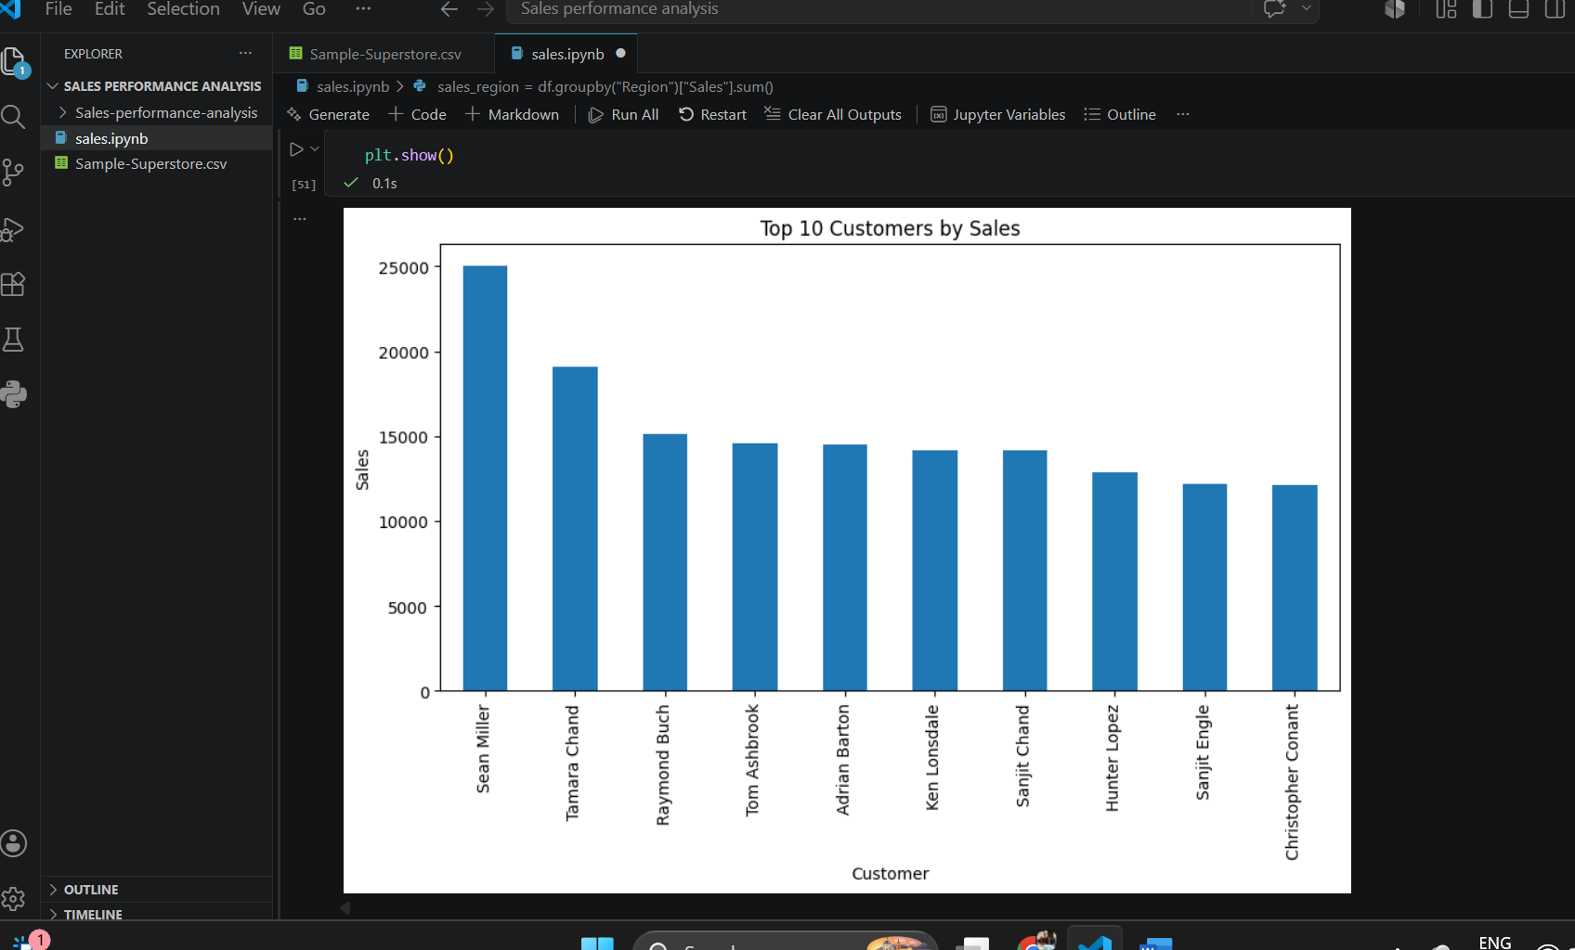
This pie chart shows sales contributions from different customer segments.
Observation:
The Consumer segment contributes the largest share of sales, making it the most important customer group.

7. Key Findings
- Technology is the highest-performing category in terms of sales and profit.
- The West region contributes a significant portion of overall revenue.
- Sales performance varies considerably across states.
- Seasonal patterns exist in monthly sales performance.
- Higher discounts tend to reduce profit margins.
- Consumer customers account for the largest share of sales.
- A limited number of customers generate a substantial percentage of total revenue.

8. Business Recommendations
Based on the analysis, the following recommendations are proposed:
- Increase focus on technology products due to strong profitability.
- Expand marketing efforts in high-performing regions and states.
- Optimize discount policies to avoid profit erosion.
- Develop customer retention strategies for top customers.
- Use seasonal trends to improve inventory planning and promotional campaigns.
- Continue monitoring regional performance to identify growth opportunities.

9. Conclusion
The Sales Performance Analysis project successfully examined the Superstore dataset using data analytics techniques. Through data visualization and exploratory analysis, valuable insights were obtained regarding product categories, customer behavior, regional performance, and profitability.
The results indicate that technology products and consumer customers play a major role in business success. Additionally, discount management and regional strategy significantly affect profitability. The insights generated from this analysis can support data-driven decision-making and contribute to improved business performance.

References
- Sample Superstore Dataset
- Python Documentation
- Pandas Documentation
- Matplotlib Documentation
- Seaborn Documentation

